

**Council of the Great City Schools Chief on Coronavirus and What's Ahead**

By [**Rick Hess**](http://blogs.edweek.org/edweek/rick_hess_straight_up) on May 12, 2020 9:00 AM

*As families, educators, and community leaders wrestle with COVID-19, we will be trying to bring conversations to readers that will be helpful in confronting the challenge.*

Mike Casserly has been the executive director of the [**Council of the Great City Schools**](https://www.cgcs.org/cgcs), a coalition of the nation's large urban public school districts, for almost three decades. I talked with Mike back in March when schools were being shuttered across the land but thought it worth checking back in to see how where things stand and what's ahead for fall. Here's what he had to say.

**Rick:** Mike, when we spoke six weeks ago, districts were just starting to adjust. Now, close to two months after school closures, what's different?

**Mike:** For one, we are all a lot more tired than when we went into this pandemic. People are really working quadruple time to address all the complications that these shutdowns have brought. Several other things are different as well—some good and some not so much. For instance, the logistics of meal deliveries have evolved over time, but they are now reasonably efficient and effective at meeting a very high volume of demand. Many districts started by delivering meals most every day, but most are now [**providing the same number of meals on a reduced number of days per week**](https://www.aei.org/research-products/report/school-district-responses-to-the-covid-19-pandemic-round-4-halfway-through-closures/) in order to reduce worker exposure to the virus. St. Louis is a good example where the school district shifted to a once-a-week distribution of kits with meals for seven days. We have also secured and distributed hundreds of thousands—possibly millions—of technology devices and hotspots to students. New York City alone has distributed some 430,000 devices. Ultimately, these logistical lessons we have learned in delivering meals and technology will put us in a better position going forward. The not so good side involves the unbudgeted expenses we are incurring for meals and devices. They are really piling up, and the scale of our longer-term revenue shortfalls is just now coming into view.

**Rick:** What have some states done that you have found especially helpful?

**Mike:** States are particularly helpful when they talk to us and do not spring decisions on us that they expect us to implement overnight. They have been the most unhelpful when they seek waivers to federal maintenance-of-effort rules and reduce their state funding allocations by the amounts that we receive in federal CARES aid.

**Rick:** What have federal policymakers gotten right and wrong during all this?

**Mike:** The initial down payment of some $13 billion in federal education aid will certainly help to offset some of the unbudgeted expenses we incurred this spring. That was something federal policymakers got right from our vantage point. There are several areas, however, where federal policymakers have made life more difficult. First, if Congress and the administration do not approve substantial additional funding, state and local revenue losses will result in teacher layoffs and cuts to other supports and services that will take a generation to recover from in terms of restoring district instructional and operational capacity. Second, federal policymakers did not do us any favors in the initial supplemental appropriations bills by not treating public school districts—or state and local governments for that matter—as employers. In fact, school districts are among the largest employers in the country. But the legislation did not treat them as such when they excluded them from payroll tax credits for employee retention or emergency paid family and sick leave. Both the Family First Coronavirus Response Act and the CARES Act prohibited school districts from offsetting our additional personnel costs against our employer share of Social Security payroll withholding payments, while granting that flexibility to private businesses. Third, the U.S. Department of Education was not very helpful in writing that there were no areas of additional flexibility needed in the Individuals with Disabilities Act after Congress invited them to submit suggestions. We think there are areas where reasonable people could agree on some temporary elasticity in the law to accommodate the special circumstances all schools are currently facing. Fourth, the department recently issued guidance that would have us spend funds on nonpoor, private school children that are not otherwise eligible for Title I services. The procedure could reduce our much-needed CARES Act allocations by hundreds of millions of dollars.

**Rick:** Where are districts at as far as planning for the summer and fall?

**Mike:** Most of our urban school districts will be holding summer school this year, but they are planning for online programming given the continuing uncertainty about how quickly states will allow schools to open (and the possibility of rolling school closures in the future). In some cases, like Boston, schools are considering limited, small-group instruction face to face with students who had not otherwise been engaged online or who are furthest behind. For the fall, districts are mostly weighing various structural or calendar options, costing them out, working on staffing issues, and articulating what high-quality instruction should look like now that we have some of the more obvious technology supply problems worked out. The complexities of the issues are mind-boggling. Everything from language screening for newly arriving immigrant students to labor negotiations over job descriptions for workers pulling multiple duties to how to assess and address the degree of unfinished learning to the cleaning of buses in between runs to accommodate staggered schedules. Many of these challenges are unprecedented, so districts are having to rethink traditional approaches and innovate in real time.

**Rick:** When it comes to remote learning, what do you see as a couple of real success stories?

**Mike:** One of our districts that is furthest along on remote learning is the 345,000-student Miami-Dade County public schools. They have distributed some 115,000 devices and trained over 20,000 teachers on a variety of instructional applications. The Florida district has been particularly aggressive in reaching out to students and has achieved a daily online student and teacher check-in rate of over 90 percent. Moreover, the district has launched a call center that is able to provide students and parents with assistance in three languages. And the district has been particularly attentive to the quality and alignment of the instructional software on the devices. They have a two-part summer school planned, and they have thought through the redeployment of underutilized buildings as part of their reopening plan. In the middle of all of this, they have also prepared and distributed some 1.5 million meals.

**Rick:** Can you talk a bit about what the budget picture looks like?

**Mike:** Based on our experience with the 2008-09 recession and the projections of many of our chief financial officers, we were estimating an average shortfall of local and state dollars of around 20 percent. That initial estimate may not be far off, as entities like the California Department of Finance have recently issued a letter to the governor warning of an $18 billion, or 22 percent, reduction to schools. Other school budgets in states like Florida expect to take a pounding because of the collapse of the tourism industry, and in Texas, revenues from oil and gas have dropped substantially. Sales-tax revenues have already taken a beating. Property taxes, usually a lagging revenue source, are also expected to drop over the next two years. Several districts, like Fresno (Calif.), are thinking about their finances according to three possible scenarios: an optimistic scenario where there are no cost-of-living increases and no revenue growth; a middle-of-the-road scenario that reflects what happened in the 2008-09 recession; and a severe scenario where the economy completely collapses and the downturn lasts for multiple years. Our 20 percent estimate is based on the second scenario, but that may be optimistic.

**Rick:** Have districts been able to save money at all with schools closed?

**Mike:** Yes, districts have saved some money because of the closures, but the savings are being more than offset by the unexpected spending on meal service and instructional devices. Areas where some savings have been realized include utilities and fuel, but the amounts are insufficient to compensate for new spending.

**Rick:** Are all staff still getting paid, or have districts started to furlough or lay off nonessential staff?

**Mike:** Staff in most districts are still being paid. Exceptions include many transportation workers, substitute teachers, and others. In addition, some districts are paying staff who are in direct contact with others, like food-service workers, at higher rates. Most cities have put into place hiring freezes at either the school or district levels as an initial step to control costs, and they will rely on regular staff attrition to realize cost savings in the short run.

**Rick:** How are you working with your districts now?

**Mike:** Essentially, we are reminding them that they do not have to reinvent everything on their own. Collaborating across districts helps. Under the aegis of the Council of the Great City Schools, urban districts are planning together and assembling working groups composed of school boards, superintendents, chief academic officers, chief information officers, chief financial and operations officers, and many others. These groups are sharing approaches and ideas, and together they are developing strategies for addressing the instructional and operational problems school districts will face in the coming months and years. The goal is to ensure that families and school and district staff will be confident returning to school either in person or online.

**Rick:** All right, last question. Two months in, what is the most heartening thing you've seen?

**Mike:** I am going to answer this question by showing you one of the many heartwarming signs that we see. This is of a young student in San Antonio whose family had just received their meal packets from the school district. In English, it reads, "God bless you. Thank you for taking some of your time so that I can have some food on my table every day."

**[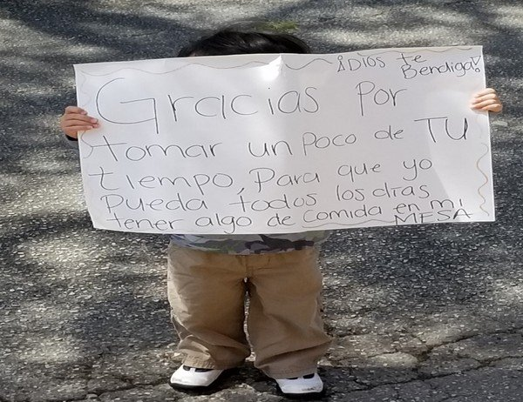](http://blogs.edweek.org/edweek/rick_hess_straight_up/assets_c/2020/05/Casserly_Child%20with%20sign-39301.html)**

Young student in San Antonio whose family had just received their meal packets thanks the school district. In English, it reads, "God bless you. Thank you for taking some of your time so that I can have some food on my table every day."

— Courtesy of the San Antonio Independent School District.

This post has been edited and condensed for clarity.